Every time you baying anything from Best buy, Circuit City, Dell, Newegg, eBay or different retailers you get cash back for your purchase !
How It Works:
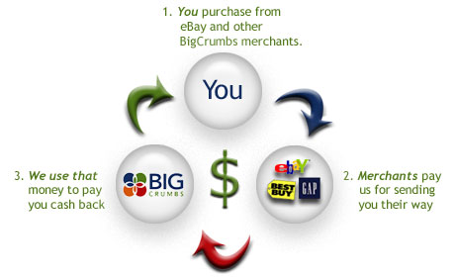

Lots of people joining .Don’t be last.
Click here (Ctrl + Click to follow link) and join in its FREE

