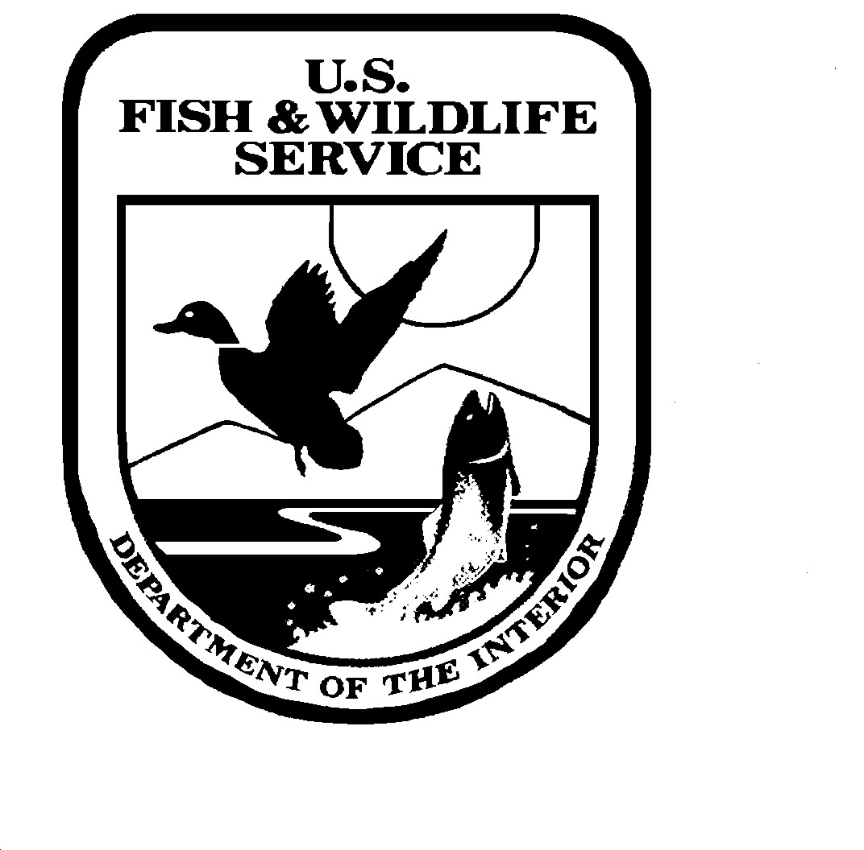
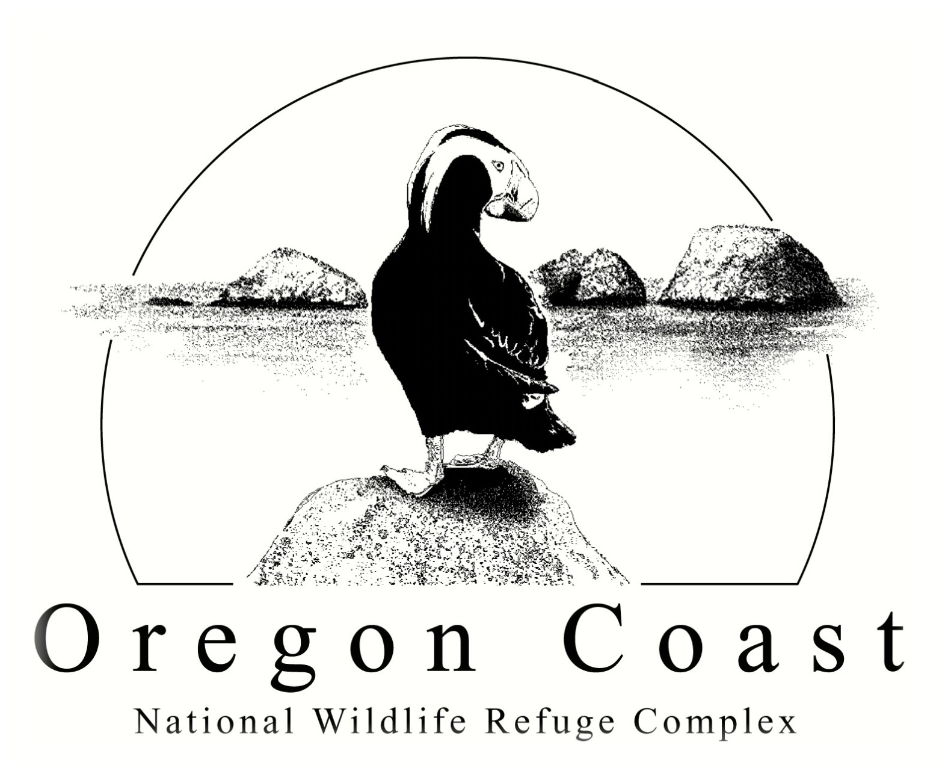
Communications Plan
Cape Meares National Wildlife Refuge
Oregon Islands National Wildlife Refuge
Three Arch Rocks National Wildlife Refuge

The U.S. Fish and Wildlife Service (Service) has initiated a Comprehensive Conservation Planning (CCP) process to guide management of Cape Meares, Oregon Islands, and Three Arch Rocks National Wildlife Refuges (NWR) for the 15 years following completion of the CCP. Public involvement in the planning process is crucial to the success of the development of a CCP. This Communication Plan identifies the timeline, strategies and key partners involved in addressing issues that are at the forefront of wildlife management on the Oregon coast and how the Service will work to ensure those issues that concern the public are communicated in a clear and effective manner.

Goals of Public Outreach and Communication
Public outreach and communication is an integral part of the CCP planning process.
Goals include:
1. Inform the public about the National Wildlife Refuge System, its mission, laws, goals, and concepts such as the CCP planning and refuge compatibility processes.
2. Inform the public about the mission and purposes of Cape Meares, Oregon Islands, and Three Arch Rocks NWR’s.
3. Increase public awareness of the threats to the seabird and marine mammal populations and habitat of Cape Meares, Oregon Islands, and Three Arch Rocks NWR’s including disturbance, habitat loss, invasive species and catastrophic oil spill events.
4. Clearly describe the biological, legal and policy limits to, and process for, decision making.
5. Inform the public and receive input regarding public use and resource management issues for Cape Meares, Oregon Islands, and Three Arch Rocks NWR’s.
6. Build long-term community support for the biological, cultural and visitor use programs approved through the CCP process.
7. Continue to build relationships between the NWR’s and coastal communities, adjacent land management agencies and organizations.
8. Continue to strengthen partnerships with local, state, tribal, and federal governments, private conservation organizations and Friends groups through open communication and input during the CCP process.
9. Ensure accurate news reports.

The Oregon Coast NWR Complex office is located in Newport, Oregon and serves as the administrative headquarters for Cape Meares, Oregon Islands, and Three Arch Rocks NWR’s. The South Coast Refuge Office, located on Bandon Marsh NWR near Bandon, Oregon manages the day-to-day operations of the southern portion of Oregon Islands NWR including the Coquille Point and Crook Point headland units.

AUDIENCE/INTERESTED PARTIES

Internal Audiences

Key personnel to keep informed include upper management within Region 1 including the Regional Director, Deputy Regional Director, Regional Chief – NWRS, Refuge Supervisor and Chief of Planning. Technical planning experts within the region and in the Washington Office will most likely be interested in viewing and commenting upon the draft CCP. Refuge managers, biologists, and park rangers from other refuges, especially Willapa Bay, Humboldt Bay and Washington Maritime, will be kept informed of the Oregon Coast NWR Complex CCP and may also serve as a source of technical expertise.

External Audiences

The list below is a summary of the entities that will be key targets during outreach for the CCP. Involved public will include stakeholders, adjacent landowners and managers and all parties with the potential to be affected by the plan and its process. Consult the CCP mailing list for details.

- Local governments including the counties of Clatsop, Tillamook, Lincoln, Lane, Coos, and Curry; and the communities of Cannon Beach and Bandon.
- State agencies including the Oregon Department of Fish and Wildlife (ODFW), Oregon Parks and Recreation Department (OPRD), Oregon Department of Land Conservation and Development - Oregon Coastal Management Program, and Oregon Department of State Lands.
- Oregon Ocean Policy Advisory Council.
- Federal agencies including NOAA Fisheries, the U.S. Coast Guard, and Bureau of Land Management (BLM).
- American Indian Governments including the Coquille Indian Tribe, Confederated Tribes of Grand Ronde, Confederated Tribes of the Siletz Indians, and Confederated Tribes of the Coos, Lower Umpqua, and Siuslaw Indians.
- Adjacent landowners.
- State and local chapters of conservation organizations.
- Local interest groups organized around/for industries or economic concerns.
- Chamber’s-of-Commerce and Visitor and Convention Bureaus.
- Public secondary schools and public and private universities.
- Land trust organizations.
- The Haystack Rock Awareness Program and Friends of Haystack Rock.
- The Friends of Southern Oregon Coastal Refuges/ Shoreline Education for Awareness (SEA).
- Friends of Cape Meares Lighthouse and Wildlife Refuge.
- Friends of Shore Acres.
- Affected businesses

ANTICIPATED ISSUES

The primary categories of issues that the USFWS anticipates addressing as part of the CCP process for Cape Meares, Oregon Islands, and Three Arch Rocks NWR’s are Resource Protection, Management (including wildlife and habitat management), and Public Use. A more detailed description for each of these issues can be found in the Issues Statements appended to the Communications Plan.

KEY MESSAGES (Public Briefing Statements)

Key Messages about the CCP and associated Environmental Assessment

• As part of the National Wildlife Refuge System Administration Act, as amended, (Refuge Administration Act) all refuges require a comprehensive conservation plan to guide their management. Upon completion, the CCP for Cape Meares, Oregon Islands and Three Arch Rocks NWR’s will guide management of these refuges for the next fifteen years.

• The CCP will be developed with involvement from local, state, tribal and federal governments, the public, conservation organizations, adjacent landowners and affected businesses.

• The CCP will be released together with an Environmental Assessment, which will describe a range of alternatives for the CCP and predict the environmental consequences anticipated under each alternative. The Refuge Project Leader has the primary responsibility to prepare the plan. The Refuge Project Leader is the primary point of contact for the public. The Regional Director, as final Decision-maker, will approve the completed CCP.

Key Messages for Cape Meares NWR

• Cape Meares NWR is located on the Pacific Coast of Oregon between Tillamook Bay and Netarts Bay and was established in 1938. The Refuge is comprised of two units separated by Cape Meares State Scenic Viewpoint, which is managed by Oregon Parks and Recreation Department (OPRD).

• Cape Meares NWR includes vertical coastal cliffs, rock outcroppings, and rolling headlands with old-growth forest dominated by Sitka spruce and western hemlock as well as a smaller section of old-growth blowdown forest. In 1987, Cape Meares NWR (excluding the Oregon Coast Trail) was designated a Research Natural Area (RNA) to further protect its unique vegetation, geology, and wildlife habitat in a naturally functioning ecosystem.

• Management programs at Cape Meares NWR are primarily concerned with preserving the old growth forest, maintaining the integrity of the RNA, protection of seabird nesting colonies and a peregrine falcon eyrie, and providing opportunities for the public to learn about the wildlife resources through wildlife viewing and interpretation on adjacent OPRD lands. A Memorandum of Agreement (MOA) between OPRD and the Service exists for cooperative management of public use on Cape Meares NWR.

Key Messages about Issues - Cape Meares NWR

Interested Parties:
OPRD
Oregon Department of Transportation
Oregon Department of Forestry
Community of Oceanside
Friends of Cape Meares Lighthouse and Wildlife Refuge
Adjacent private landowner
City of Tillamook
Tillamook County

Issue #1: Resource Protection.

Key Messages

• Cape Meares NWR’s designation as a Research Natural Area will continue to be a mandate for allowing natural processes to continue without interference from humans.

• Invasive species are a major problem on public lands throughout the United States, including National Wildlife Refuges. On refuges, they compete with native species for food and space or otherwise decrease the quality of habitat for native species. Some invasive species cause direct mortality of native species. The Service is concerned with threats posed to native habitats and wildlife at Cape Meares from invasive plants like English ivy and tansy ragwort and mammals such as introduced rats, red fox and feral cats. In 2004, an Environmental Assessment was written to address the potential of mammalian predation of seabirds at colonies on Oregon Islands and Three Arch Rocks NWR and adjacent mainland areas which includes the mainland colonies at Cape Meares NWR. As part of the CCP, the Service will address how to prevent the introduction and spread of invasive plants on Cape Meares NWR.

• The Service is concerned about the possibility of wildfire spreading from adjacent OPRD and private lands onto Cape Meares NWR. The Service completed a fire management plan in 2003, which specifies allowable techniques and priorities for wildfire suppression.

Issue #2: Management of refuge resource and public use facilities.

Key Messages

• Cape Meares NWR partially surrounds OPRD’s Cape Meares State Scenic Viewpoint. The Service is concerned about balancing public use and wildlife protection and will ensure public use is managed to keep visitors in areas where public use facilities have been constructed and to prevent visitors from areas where wildlife and habitat are sensitive to human disturbance. The Service will work with OPRD to determine how to best meet public use needs while safeguarding the habitat and wildlife it is mandated to protect.

• The Service manages a volunteer program that places refuge volunteers on OPRD lands during the spring and summer to protect sensitive wildlife species from disturbance and enhance visitor experience through interpretation. The Service will strive to maintain the volunteer program with support from OPRD.

Issue #3: Public Use.

Key Messages

• The FWS has a commitment to provide wildlife-dependent public use on NWRs and the Refuge Administration Act mandates safe and compatible wildlife-oriented recreation opportunities. The Service will work with OPRD to continue current interpretation programs for visitors that occur on lands owned by OPRD, but overlook or are adjacent to Cape Meares and Oregon Islands NWRs.

• Wildlife dependent uses are defined by law and policy as wildlife observation and photography, hunting, fishing, interpretation, and environmental education. These uses are legislatively defined as appropriate uses of refuge lands, and all of these uses are to receive equal consideration and have priority over all other uses. Not all uses occur on all refuges because they must be compatible with the purposes of the refuge.

• The Service is concerned about activities that the public may engage in or request that are gaining popularity on other public and private lands but are not dependent on wildlife. Some of these may include tree climbing, geocaching and harvesting mushrooms or native plants. The Service will analyze new activities, if requested, to determine their appropriateness and, if warranted, their compatibility with refuge purposes.

Key Messages for Oregon Islands NWR and Three Arch Rocks NWR

• Oregon Islands NWR includes 1,853 rocks, reefs and islands, two headland units and spans 320 miles of the Oregon coast. To be within Oregon Islands NWR, a rock, reef or island must be separated from the mainland and above the surface of the sea at mean high tide.

• All of the rocks, reefs, and islands within Oregon Islands NWR, excepting Tillamook Rock, are designated Oregon Islands Wilderness.

• The two headland units are Coquille Point and Crook Point. The nineteen-acre Coquille Point Unit is located in the town of Bandon, and provides a buffer between residential development and seabird nesting colonies on adjacent off-shore rocks and islands. A designated interpretation trail is open to the public for wildlife observation, photography and interpretation.

• The 134-acre Crook Point Unit is located approximately12 miles south of Gold Beach and is closed to the public. This unit, which contains numerous rare plant species, undisturbed cultural resource sites, unique geological formations, serves to protect major near-shore seabird colonies from trespass. The Crook Point Unit is managed as a biological reserve and is designated a Natural Heritage Conservation Area.

• The majority of the estimated 1.2 million seabirds nesting in Oregon are found on Oregon Islands NWR, as are a large proportion of the state’s seals and sea lions (pinnipeds). Oregon Islands NWR provides breeding habitat for 13 species of seabirds and four species of pinnipeds. To protect wildlife resources, all refuge rocks, reefs, and islands, as well as the Crook Point Unit, are closed to public access.

• Three Arch Rocks NWR is an off-shore island refuge located ½ mile west of the town of Oceanside. It is comprised of nine rocks and islands with a total land area of 15 acres. The refuge, established in 1907, is the first National Wildlife Refuge west of the Mississippi River. Three Arch Rocks NWR is a designated National Wilderness Area and it supports Oregon’s largest seabird nesting colony with more than 230,000 nesting birds representing 12 species.

• Threatened and endangered species using Three Arch Rocks NWR are California brown pelican, bald eagle and Steller sea lion. In order to protect sensitive seabird and marine mammal populations, Three Arch Rocks NWR is closed to public access.

• A 500’ seasonal buffer zone administered by the Oregon State Marine Board protects nesting seabirds and breeding Steller sea lions at Three Arch Rocks. The buffer zone prohibits watercraft from approaching closer than 500’ from the three large rocks from May 1 to September 15 annually.

Key Messages about Issues - Oregon Islands and Three Arch Rocks NWRs

Interested Parties:

Adjacent landowners
Airports
Anglers
Bicyclists
Bureau of Land Management
Canoe/kayak users & outfitters
Chamber’s of Commerce
City of Bandon
City of Tillamook
Coastwatch
Commercial fishers & businesses
Community of Oceanside
Curry County
Federal Aviation Administration
Friends of Cape Meares Lighthouse and Wildlife Refuge
Friends of Haystack Rock
HAM radio operators
Hikers
Horseback riders
National Audubon Society
NOAA-Fisheries
ODFW
Oregon Department of Forestry
Oregon Department of Land Conservation and Development – Oregon Coastal Management Program
Oregon Department of State Lands
Oregon Department of Transportation
Oregon Native Plant Society
Oregon Ocean Policy Advisory Council
Oregon Parks and Recreation Department
Oregon State Marine Board
Oregon State University
Other universities/ colleges
Pilots, air tour companies, seaplanes
Point Reyes Bird Observatory
Port of Bandon
Recreational divers
School Districts
Shoreline Education for Awareness
Sport fishing interests
State airport commission
Tillamook County
Tribes
U.S. Coast Guard
University of Oregon – OIMB
USFS
USGS-Biological Resources Division
Visitor and Convention Bureaus

Aviators/Pilots
Commercial Divers

Issue #1: Resource Protection.

Key Messages

• Nearly 1.2 million seabirds, and four species of pinnipeds including threatened Steller sea lions, depend on the habitat and sanctuary of the rocks, reefs and islands of Oregon Islands and Three Arch Rocks NWRs to fulfill part of their life history requirements including breeding and resting.

• Both seabirds and pinnipeds are sensitive to human induced disturbance. During even a single disturbance event, large numbers of seabird eggs and chicks can be destroyed and pinnipeds may accidentally crush their pups while trying to evade the source of the disturbance. Due to limited Service and local law enforcement capability for these islands, illegal activities such as climbing on rocks and general trespass by boaters and fishermen, whether intentional or inadvertent, occur regularly, resulting in disturbance to seabirds and marine mammals.

• Through the CCP process, the Service will determine the most frequent human caused disturbances to wildlife and where they are occurring. The Service will propose methods to reduce or eliminate human caused disturbances through education, training and enforcement.

• Education efforts by Service volunteers, refuge Friends groups and conservation organizations have a positive impact in reducing wildlife disturbances at specific locations along the coast. As part of this CCP, the Service will propose the development of a volunteer training program to be presented annually to Service, OPRD, U.S. Forest Service and Bureau of Land Management staff and volunteers who work near refuge rocks and islands. The program will help educate the public about the sensitivity of wildlife to human disturbance. Development of programs and increased volunteer efforts are Service staff and funding dependent.

• The Service may expand its volunteer program to cover more sites along the coast near rocks and islands that are most vulnerable to disturbance, and will seek public input as to how this can be most successful. The Service will continue to support its Friends groups and other conservation organizations that currently work to protect refuge wildlife through outreach and education.

• Three Arch Rocks NWR has an official 500’ seasonal closure (Buffer Zone) to reduce breeding season impacts to seabirds and pinnipeds from disturbance events caused by boaters. For Oregon Islands NWR, the Service requests that boaters maintain a 500’ distance from all offshore rocks, reefs and islands, but this is only a recommendation and not a regulation.

• Non-motorized and motorized boaters, including recreational and commercial fishing boats, kayakers, and surfers, are often not aware of the disturbance their proximity poses to the wildlife on the rocks and islands. The Service is concerned about reducing and eliminating this disturbance to wildlife and through education and interpretation has informed the public about reducing their impact. The Service will work with agency and Friends group partners to explore additional measures to reduce trespass and wildlife disturbance through education and enforcement.

• The Service does not have jurisdiction over the waters surrounding the rocks, reefs and islands but wildlife disturbance and trespass violations are enforceable through Federal Refuge Regulations (Code of Federal Regulations CFR 50). The Service does not have a Refuge Law enforcement Officer dedicated solely to protecting coastal wildlife resources in Oregon. Due to limited staff and funding, law enforcement coverage has been spotty. Consequently, the Service is very concerned about the extremely limited law enforcement capability. As part of the CCP the Service will demonstrate the need for full-time dedicated staff Law Enforcement Officers and will investigate strategies for developing and implementing effective law enforcement assistance agreements with other agencies to protect the refuges’ trust resources.

• Many of the rocks and islands of Oregon Islands NWR are close to the shoreline, which is managed by OPRD. Public uses managed by OPRD which occur on the shoreline adjacent to Refuge lands are identified by the Service as potential concerns to the protection of breeding and resting wildlife. The CCP will work with OPRD to identify nearshore public uses that disturb wildlife and how they can be managed or eliminated to reduce the impact.

• Aerial disturbance by commercial, recreational and government aircraft to seabird and pinniped populations on rocks, reefs, islands and headlands are of concern to the Service. The Federal Aviation Administration aeronautical charts request a 2,000 foot above ground level (AGL) vertical distance above all NWRs and Wilderness Areas but this is strictly a request and not an enforceable regulation. Only wildlife disturbance resulting from low overflights is enforceable. This CCP will examine ways to engage the public, special interest groups, and other agencies in educating pilots regarding the potential for, results of, and ways to reduce this type of disturbance when seabirds and marine mammals are present on Oregon Islands and Three Arch Rocks NWR.

Issue #2: Management.

Key Messages

• The large populations of seabirds and marine mammals concentrated on the refuge rocks, reefs and islands during the breeding season make them vulnerable to catastrophic losses from oil spills, rat spills, disease outbreaks, angler/ animal/ boat stranding, invasive species and concentrations of marine debris. Headlands and cliff faces are also vulnerable to wildfire spread from adjacent lands.

• Standardized collection of baseline population data, and development of contingency and response plans including formal coordination and assistance agreements, are critical to minimizing habitat and wildlife damage in the event of a catastrophe. As part of the CCP the Service will develop the methods, protocols, and agreements needed to obtain the necessary baseline data and to coordinate timely and effective responses to catastrophic events. Specifically the Service will summarize the existing Wildlife Disease Contingency, Fire Management and Predator Damage Management Plans and incorporate them into the CCP by reference.

• The Refuge AdministrationAct requires the Service to monitor the status and trends of fish, wildlife, and plants on each refuge in the System. An inventory and monitoring plan has not been developed for all resources of concern on Oregon Islands and Three Arch Rocks NWRs. In addition, baseline surveys of many species and their associated habitats are lacking due to limited staffing and funding. This lack of data hinders the Refuge’s ability to respond effectively to resource impacts and to use adaptive management to evaluate the effectiveness of its management practices. The CCP will examine these inventory, monitoring and research needs and the public’s role in determining and meeting these needs. In addition, the Service will review its funding and staffing needs for monitoring wildlife and habitat on refuge lands.

• Rapid development along the Oregon coast is bringing with it a host of issues and problems that have the potential to negatively affect refuge resources. The CCP will examine the issues that pose threats to wildlife and will work with other agency partners and city and county governments to provide management recommendations that minimize harmful effects from these development-related or increase in human population issues. The Service has already identified the following issues as potentially threatening: light pollution from residences and businesses, domestic animal trespass, dumping on refuge lands, wildfire, and increasing visitation.

• The Service will identify issues that could threaten the biological and cultural integrity of the Crook Point Unit and will provide alternatives for managing these issues to reduce or eliminate their threat. These include wildfire, control of invasive plants and animals, and trespass.

Issue #3: Public Use.

Key Messages

• The FWS has a strong commitment to provide wildlife-dependent public use on NWRs and the Refuge Administration Act encourages (mandates) safe and compatible wildlife-oriented recreation opportunities.

• Wildlife dependent uses are defined by law and policy as wildlife observation and photography, hunting, fishing, interpretation, and environmental education. These uses are legislatively defined as appropriate uses of refuge lands, and all of these uses are to receive equal consideration, and have priority over all other uses if they are determined to be compatible with the purposes of the refuge. Not all uses occur on all refuges because they must be appropriate and compatible with the purposes of the refuge.

• The rocks, reefs and islands of Oregon Islands and Three Arch Rocks NWR’s are closed to public use to protect seabirds and marine mammals from human disturbance and to protect sensitive habitats from destruction. However, the Service works with partners to offer four of the six priority uses, wildlife photography, observation, interpretation and environmental education, at many offsite locations. These offsite areas are on the mainland and under management of the Service or a state or other federal agency.

• The Service will work with partners to identify additional locations where offsite viewing of refuge rocks and islands can be improved and where placement of interpretive facilities and/or signage would be appropriate to inform the public about the wildlife and to educate them about the potential for and impacts of disturbance to wildlife.

• There may be some interest in access to the Crook Point Unit for interpretive purposes. As part of the CCP the Service will determine if this and any other limited public uses are appropriate and compatible for the Crook Point Unit.

• The Coquille Point Unit provides opportunities for public use and has facilities including a paved trail accessible for people with disabilities, interpretive panels, two stairways to the beach, a sidewalk and parking lot, and unfenced viewing areas. Wildlife dependent public uses include wildlife observation, photography, interpretation, and environmental education.

• There are non-wildlife dependent activities that occur on or adjacent to the Coquille Point Unit including un-authorized bicycle riding, geocaching, dog walking, kite flying, motorized and non-motorized model aircraft flying, and paragliding. Many of the non-wildlife dependent activities are associated with the adjacent OPRD managed shoreline. The CCP will examine the management of Coquille Point Unit public use and associated facilities from many aspects including wildlife disturbance, restrictions, liability, compatibility, and future needs.

Key Public Involvement Dates
The following is a timeline of the milestones for development of the CCP and Environmental Assessment for Cape Meares, Oregon Islands and Three Arch Rocks NWR.

Pre-planning CCP documents to Regional USFWS office September 2006

Notice of Intent to affected agencies, Notice placed in Federal Register October 2006

Initiate public outreach through scoping at public meetings November 2006

Public review of Draft Environmental Assessment and CCP August 2008

Final CCP February 2009

Action Plan and Tools

The core team will use this action plan to initiate and foster an ongoing dialogue with the public, agencies and organizations regarding the CCP process. The plan will provide important information about target audiences, an extensive list of communication tools, team member responsibilities and a comprehensive mailing list (currently under development).

Target Audience

Creating an aware public is the first step in producing dynamic public involvement. Consequently, a comprehensive list of potential audiences, their interests and the tools to reach them was developed.

PUBLIC OUTREACH PLAN: ACTION PLAN AND TOOLS

TARGET AUDIENCES

a) Elected Officials

All local, state, and federal elected officials with interest in the Refuges, and within whose legislative districts the Refuges lie, will be contacted to inquire as to their level of interest in the CCP process, and will be included on the mailing list for planning updates and other materials. Depending upon level of interest, we will communicate with elected officials using a variety of communication methods (e.g. face-to-face briefings, tours of refuges). Each elected official will receive a complete copy of the draft and final CCP/EA.

b) Tribal Coordination
The following tribes could have interests in the CCP process: the Coquille Indian Tribe; Confederated Tribes of the Coos, Lower Umpqua, and Siuslaw Indians; Confederated Tribes of Grand Ronde, and Confederated Tribes of the Siletz Indians. These tribes will be fully included in our planning process and the designated contact person will be contacted personally by the Project Leader prior to each public input opportunity.
c) Agency Outreach

Key state agencies that will be involved are Oregon Department of Fish and Wildlife and Oregon Parks and Recreation Department. Designated staff from these agencies have been invited to be extended team members, and will be asked to submit comments regarding the CCP during the draft review phase. The invitation to submit comments will be issued with a letter to the responsible official of each agency or local branch.

d) Interest Group Meetings and Briefings

Many recreation, conservation, and industry organizations are active along the Oregon coast. Some of these organizations, such as Refuge Friends groups, have worked extensively with the refuge in the past. Others, including marine-based recreational fishing and boating groups, are little known to the Refuge. During this CCP process Refuge staff will make a concerted effort to identify key organizations and user groups and to ensure that these entities and organizations receive Refuge mailings. Refuge staff will meet and make presentations to community groups upon request. In certain situations we may initiate a meeting with a particular group to share information and clarify misunderstandings. These types of meetings will be conducted so as to comply with guidance of the Federal Advisory Committee Act (FACA).

f) General Public

The general public is a key audience of interest. This audience will be reached through press releases, planning updates, public open houses, and the Internet. See below for more of these communication tools.

Communication Tools

Different audiences respond to different outreach techniques; therefore a diverse selection of potential communication tools will be developed.

a) Planning Updates
Planning updates will be completed at pertinent points in the planning process and will be mailed out to all parties on the mailing list including coastal public libraries. Planning updates will be written to provide specific information about the evolving CCP/ Environmental Assessment including but not limited to: initiation of public outreach and scoping, announcement of public meetings, results of initial scoping, presentation of preliminary alternatives, goals and objectives, presentation of draft CCP, solicitation of public review, results of public comments, and release of the final CCP.

b) Media Outreach
Press releases will be prepared simultaneously with any notice in the Federal Register, and will be sent to all media on the mailing list. Generally press releases will coincide with the passage into each new phase of the planning process (e.g., initiation of scoping, release of draft plan, release of final plan, etc.). Press releases will also be prepared in advance of any public meeting, and following any significant meetings or workshops. The press releases will concisely summarize the event and will be accompanied by photos when appropriate.

Press stories and any requests for more in-depth information by the media will be accommodated by refuge staff as time allows. The Project Leader will be the key responsible official to coordinate media interview and story requests.

Federal Register notices will be published in accordance with government policies, but will not be considered a substitute for mass media press releases.

c) Public Meetings/Open Houses
In addition to briefings for elected officials, tribes, key agencies, interest groups if needed or requested, public meetings are held for the general public. The initial scoping meetings were lightly attended and public comments were captured on flip charts and transcribed.

All Public Meetings were advertised by the following:
● A press release was issued to all media on the mailing list
● A notice in a planning update
● An announcement posted on the Oregon Coast NWR Complex website

d) Internet

The Oregon Coast NWR Complex maintains a website at www.fws.gov/oregoncoast/. The website offers an opportunity to reach the public via the internet. Links to planning updates and draft and final plans will be posted on the website and available for download by the public in Adobe Acrobat pdf format. A link to the free Adobe Acrobat Reader will be maintained on the same page so that interested readers may download the reader to view the pdf.

The Oregon Coast NWR Complex maintains the email address oregoncoast@fws.gov to receive public comments for the CCP, and will post this address on all planning updates. The Supervisory Park Ranger will monitor this e-mail address on a regular basis.

e) Track and File Public Comments
Refuge staff and External Affairs will monitor coastal and Willamette Valley newspapers for articles about the refuge. Clippings of all articles and letters to the editor will be maintained in a file, filed chronologically, and indexed and archived. Periodically a copy of the index (and any key articles/letters) will be shared with the Division of Planning and Visitor Services, External Affairs and upper management. All articles published regarding this CCP will be scanned for the electronic record.

All letters and comment forms from the public will be kept on file at the refuge. A numbering system will be devised to track comments chronologically. At key junctures in the process, public comment will be analyzed and summarized. This analysis will be shared with Planning and Visitor Services, External Affairs and upper management.

Mailing List
The mailing list for the CCP will be comprehensive and shall include Service Regional and Washington Office representatives, Oregon Congressional delegation, Oregon governor, the Oregon Department of Fish and Wildlife, Oregon Department of Parks and Recreation, Oregon Department of Land Conservation and Development - Oregon Coastal Management Program, Oregon Department of State Lands, U.S. Forest Service, U.S. Bureau of Land Management, Tribal governments, local and county governments, refuge friends groups, conservation organizations, sport and commercial fishing groups, and members of the public identified by Service staff or others.
Prepared By:

Rebecca Chuck, Deputy Project Leader Date

Roy Lowe, Project Leader Date

Reviewed By:

Ben Harrison, Planning Team Leader Date

Charles Houghten, Chief, Division of Refuge Planning and Visitor Services Date

David Patte, Assistant Regional Director, External Affairs Date

